Chapter 1: Linear Regression with One Predictor Variable

Introduction

Main purpose of statistics: Make inferences about a population through the use of a sample.

Suppose we are interested in estimating the average GPA of all students at UNL. How would we do this? (Assume we do not have access to any student records.)

  - Define the random variable: let Y denote student GPA
  - Define the population: all UNL students
  - Define the parameter that we are interested in: μ = population mean GPA
  - Take a representative sample from the population: suppose a random sample of 100 students is selected
  - Calculate the statistic that estimates the parameter: 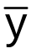 = observed sample mean GPA
  - Make an inference about the value of the parameter using the statistical science: construct confidence intervals or hypothesis tests using the sample mean and sample standard deviation

The diagram below demonstrates these steps. Note that not all GPAs could be shown in the diagram.
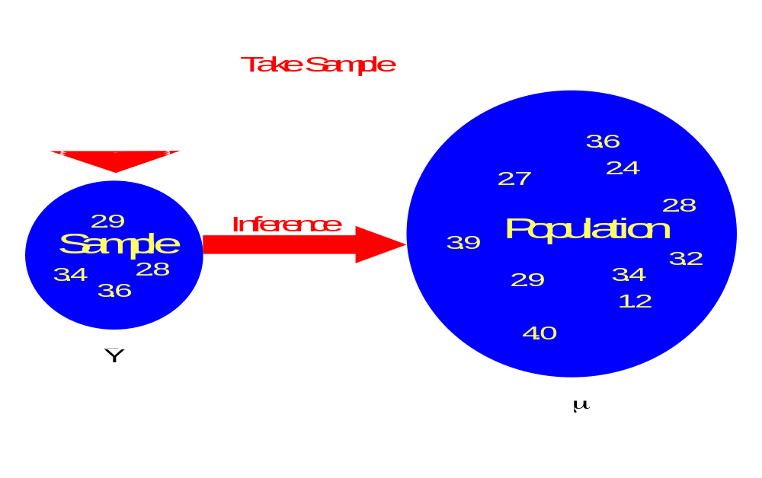

What factors may be related to GPA?
- High school (HS) GPA
- ACT score
- Involvement in activities
- Etc.

Suppose we are interested in the relationship between college and HS GPA and we want to use HS GPA to predict college GPA. How could we do this? Assume we do not have access to any student records.

Use similar steps as on page 1.1, but now with regression models.

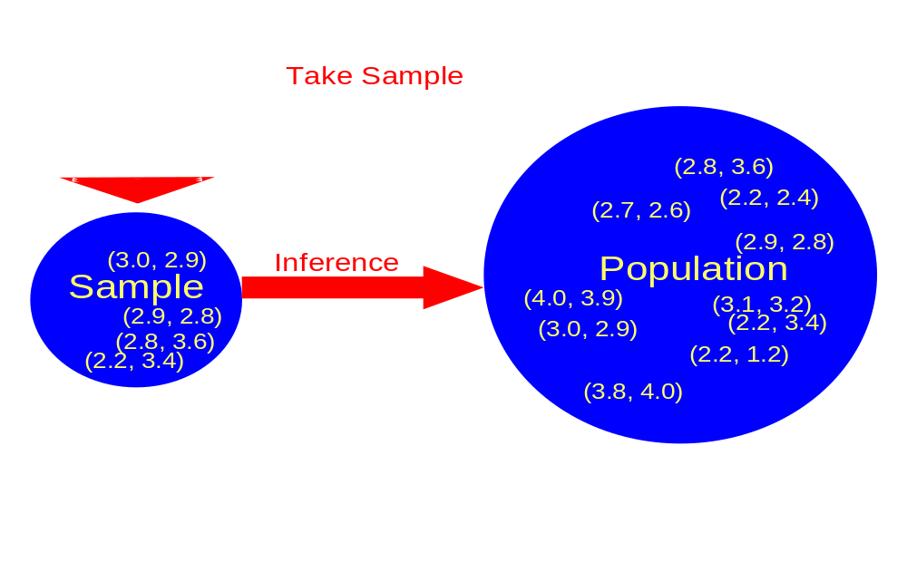
Data shown as: (HS GPA, College GPA)

Example: HS and College GPA (gpa.xls)

A random sample of 20 UNL students is taken producing the data set below (data is different from above). Don’t worry about capital or lowercase letters being used for X and Y below.
Student | X (HS GPA) | Y (College GPA)
1 | X₁=3.04 | Y₁=3.10
2 | X₂=2.35 | Y₂=2.30
3 | 2.70 | 3.00
4 | 2.05 | 1.90
5 | 2.83 | 2.50
6 | 4.32 | 3.70
7 | 3.39 | 3.40
8 | 2.32 | 2.60
9 | 2.69 | 2.80
10 | 0.83 | 1.60
11 | 2.39 | 2.00
12 | 3.65 | 2.90
13 | 1.85 | 2.30
14 | 3.83 | 3.20
15 | 1.22 | 1.80
16 | 1.48 | 1.40
17 | 2.28 | 2.00
18 | 4.00 | 3.80
19 | 2.28 | 2.20
20 | 1.88 | 1.60

Scatter plot of the data:
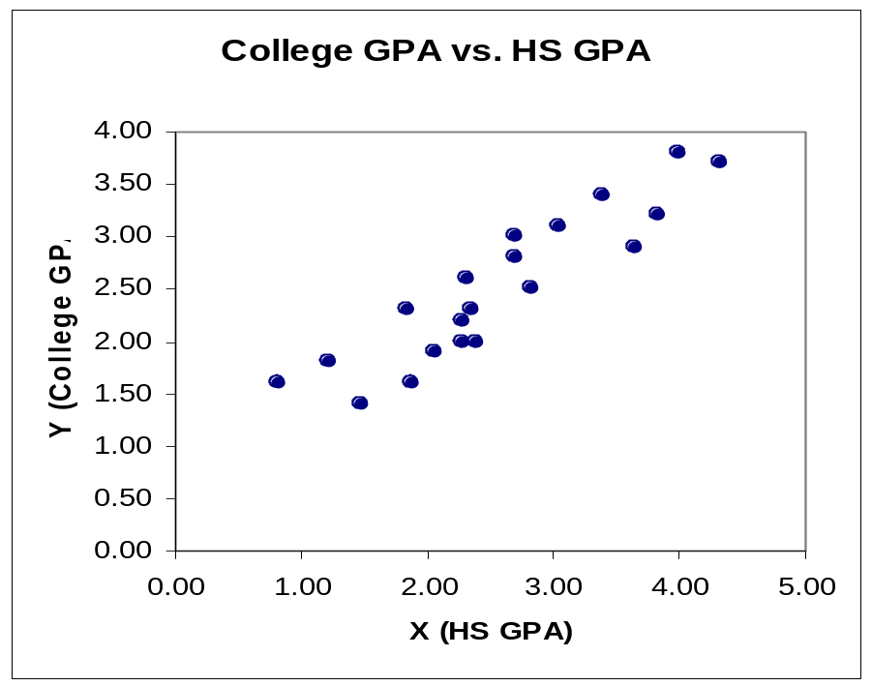
Regression allows us to develop an equation, like  = 0.71 + 0.70*(HS GPA), to predict College GPA from HS GPA.
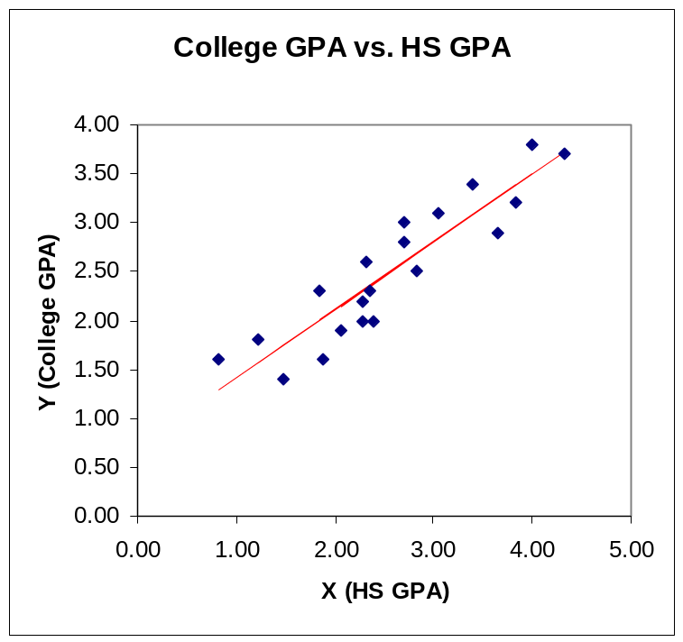

Origins of Regression (p. 5 from KNN):

“Regression Analysis was first developed by Sir Francis Galton in the latter part of the 19th Century. Galton had studied the relation between heights of fathers and sons and noted that the heights of sons of both tall & short fathers appeared to ‘revert’ or ‘regress’ to the mean of the group. He considered this tendency to be a regression to ‘mediocrity.’ Galton developed a mathematical description of this tendency, the precursor to today’s regression models.”

Note that I will use KNN to abbreviate Kutner, Nachtsheim, and Neter

Algebra Review:

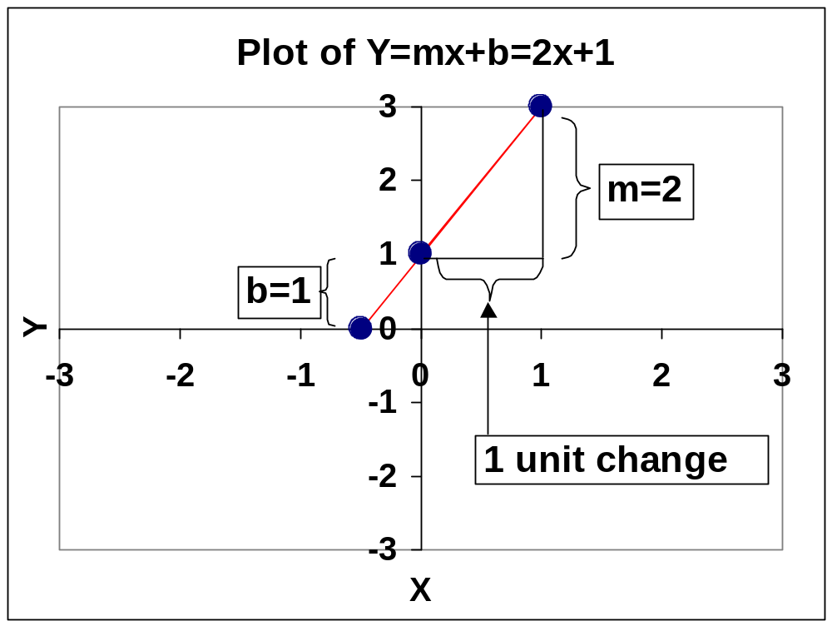
X | Y
-1/2 | 0
0 | 1
1 | 3

Y = dependent variable
X = independent variable
b = y-intercept
m= slope of line; measures how fast (or slow) that y changes as x changes a by one-unit increase

Goal of Chapter 1:
Develop a model (equation) that numerically describes the relationship between two variables using simple linear regression

Simple – one variable predicts another variable
Linear – no parameter will appear in an exponent or is divided by another parameter… (see model)

Suppose you are interested in studying the relationship between two variables X and Y
(X may be HS GPA and Y may be college GPA)

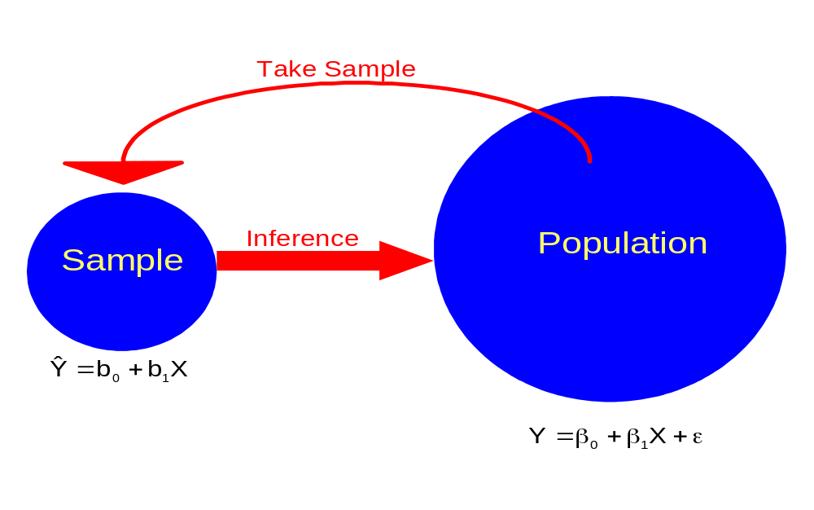
where

Y = Response variable (a.k.a., dependent variable)
X = known constant value of the predictor variable
(a.k.a, independent variable, explanatory variable,
covariate)
Y = β_{o} + β₁X+ ε is the population simple linear regression
model
- β_{o} = y-intercept for population model
- β₁ = slope for population model
- β_{o} & β₁ are unknown parameters that need to be estimated
- ε = random variable (random error term) that has a normal probability distribution function (PDF) with E(ε) = 0 and Var(ε) = 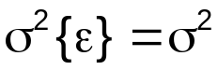; there is also an “independence” assumption for ε that will be discussed shortly
- Notice that X is not a perfect predictor or of Y
- E(Y)=β_{o} + β₁X what Y is expected to be on average for a specific value of X since

E(Y) = E(β_{o} + β₁X+ ε)
= E(β_{o}) + E(β₁X) + E(ε)
= β_{o} + β₁X + 0
= β_{o} + β₁X

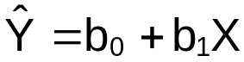 is the sample simple linear regression model (a.k.a., estimated regression model, fitted regression line)
- estimates E(Y)=β_{o} + β₁X
- b₀ is the estimated value of β_{o}; Y-intercept for sample model
- b₁ is the estimated value of β₁; slope for sample model
- More often, people will use 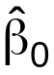 and 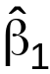 to denote b₀ and b₁, respectively
- Formally,  is the estimated value of E(Y) (a.k.a., fitted value); is the predicted value of Y (IMS Bulletin, August 2008, p. 8)
- Finding b₀ and b₁ is often referred to as “fitting a model”

Remember that X is a constant value – not a random variable:
- Notationally, this is usually represented in statistics as a lower case letter, x. KNN represents this as an upper case letter instead. Unfortunately, KNN does not do a good job overall with differentiating between random variables and observed values. This is somewhat common in applied statistics courses.
- In settings like the GPA example, it makes sense for HS GPA to be a random variable. Even if it is a random variable, the estimators derived and inferences made in this chapter will remain the same. Section 2.11 will discuss this some and STAT 970 discusses it in more detail.

Suppose we have a sample of size n and are interested in the i^{th} trial or case in the sample.
- Y_{i} = β_{o} + β₁X_{i}+ ε_{i} where ε_{i} ~ independent N(0,σ²)
- E(Y_{i}) = β_{o} + β₁X_{i}
- 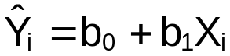

Below are two nice diagrams showing what is being done here.
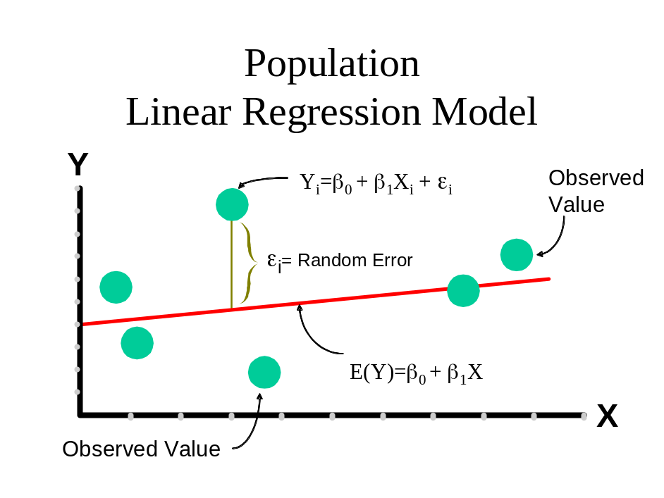

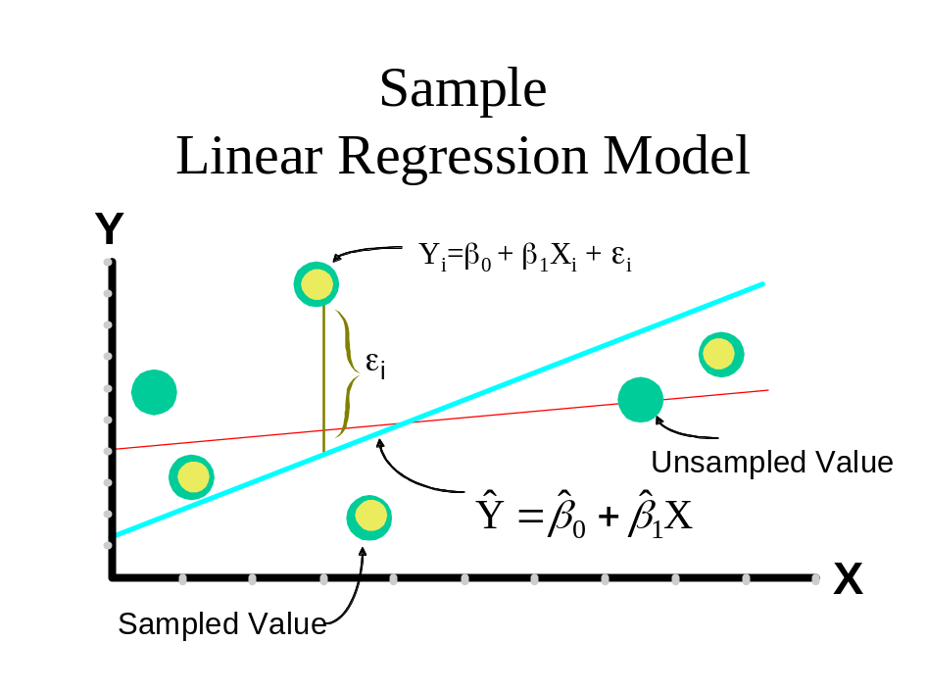
Calculation of b₀ and b₁:

The formulas for b₀ and b₁ are found using the the method of least squares (more on this later):

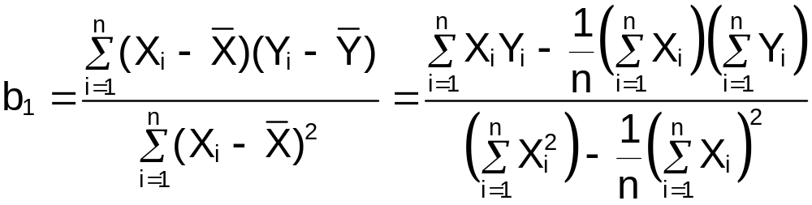
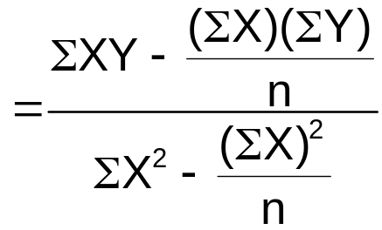

where ΣX assumes summing from i=1,…,n

b₀ =  - b₁

Example: What is the relationship between sales an advertising for a company?

Let X = Advertising ($100,000)
Y= Sales units (10,000)

Assume monthly data below and independence between monthly sales.

 | X | Y | X² | Y² | X*Y
 | X₁=1 | Y₁=1 | 1 | 1 | 1
 | X₂=2 | Y₂=1 | 4 | 1 | 2
 | 3 | 2 | 9 | 4 | 6
 | 4 | 2 | 16 | 4 | 8
 | 5 | 4 | 25 | 16 | 20
Σ | 15 | 10 | 55 | 26 | 37

(Ex. ΣX²=55)

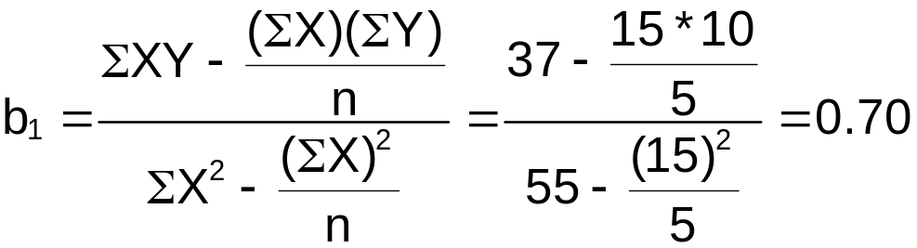
b₀ = - b₁ = 10/5 – (0.70)∗15/5 = 2-2.1 = -0.1

= -0.1 + 0.7∗X

Scatter Plot: A plot where each observation pair is plotted as a point

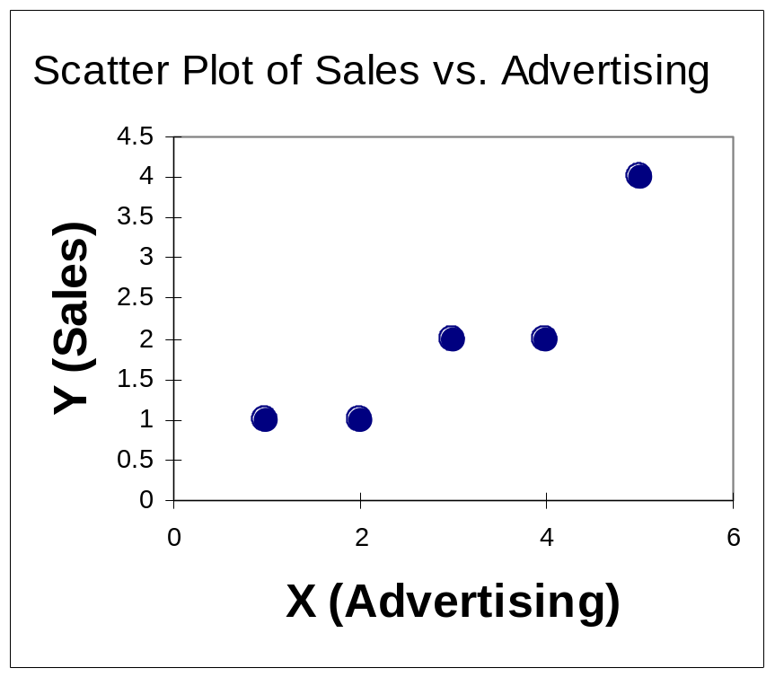

Scatter Plot with sample regression model:
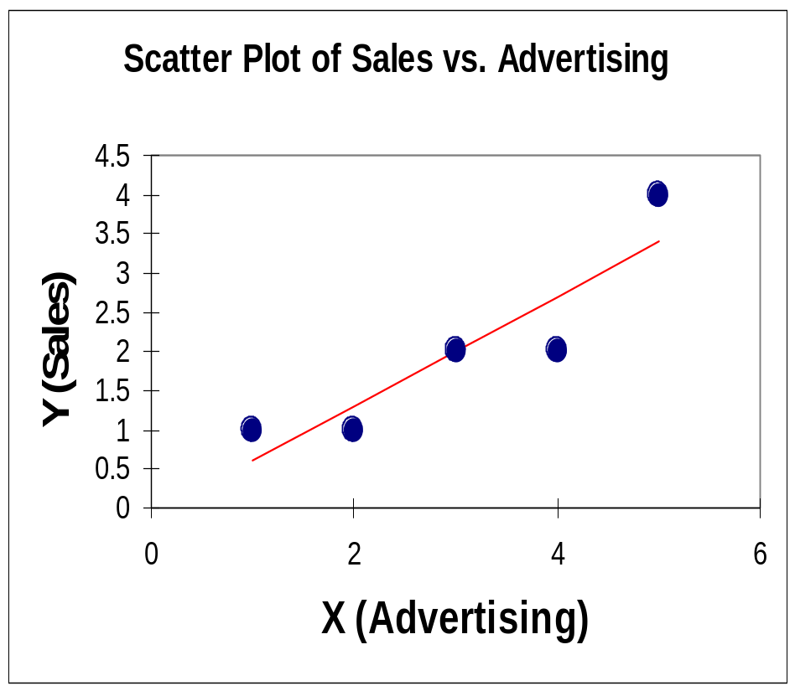

X | Y |  | Y-
1 | 1 | 0.6 | 0.4
2 | 1 | 1.3 | -0.3
3 | 2 | 2 | 0
4 | 2 | 2.7 | -0.7
5 | 4 | 3.4 | 0.6

Suppose X = 1. Then = -0.10 + (0.70)∗1 = 0.6

Residual (Error)

e_{i} = Y_{i} – 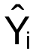
= observed response value – predicted model value.

This gives a measurement of how far the observed is from the predicted.

Obviously, want these to be small

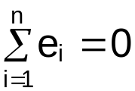

Example: Sales and advertising

What does the sales and advertising sample model mean? Remember advertising is measured in $100,000 units and sales is measured in 10,000 units.

- Estimated slope b₁ = 0.7:
Sales volume (Y) is expected to increase by
(0.7) ∗10,000 = 7,000 units for each 1∗100,000 = $100,000 increase in advertising (X).

- Use model for estimation:

Estimated sales when advertising is $100,000.

= -0.10 + 0.70∗1 = 0.60
Estimated sales is 6,000 units

Estimated sales when advertising is $250,000.

= -0.10 + 0.70∗2.5 = 1.65
Estimated sales is 16,500 units

Note: Estimate E(Y) only for min(X) ≤ X ≤ max(X)

Why?

Least Squares Method Explanation: Method used to find equations for b₀ and b₁.

Below is the explanation of the least squares method relative to the HS and College GPA example.

- Notice how the sample regression model seems to go through the “middle” of the points on the scatter plot. For this to happen, b₀ and b₁ must be -0.1 and 0.7, respectively. This provides the “best fit” line through the points.

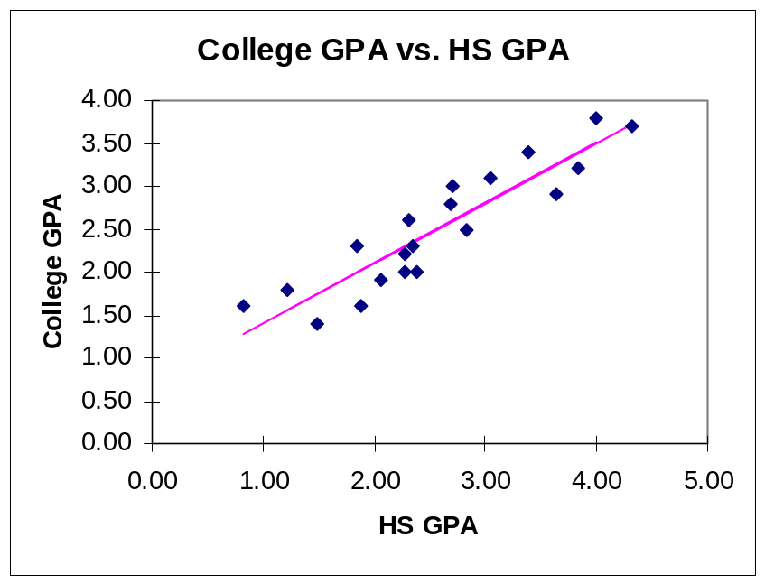

- The least squares method tries to find the b₀ and b₁ such that SSE = 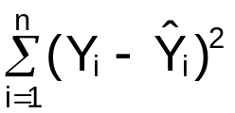 = 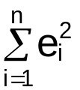 is minimized (where SSE = Sum of Squares Error). These formulas are derived through using calculus (more on this soon!).

- Least squares method demonstration with least_squares_demo.xls :
  - Uses the GPA example data set with b₀ = 0.7060 and b₁ = 0.7005
  - The demo examines what happens to the SSE and the sample model’s line if values other than b₀ and b₁ are used as the y-intercept and slope in the sample regression model.
  - Below are a few cases:

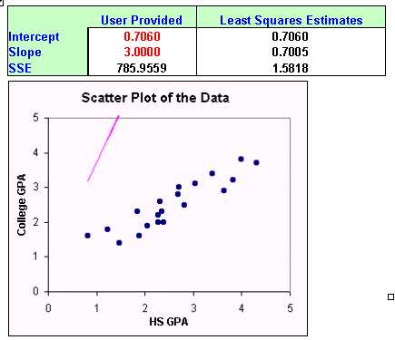
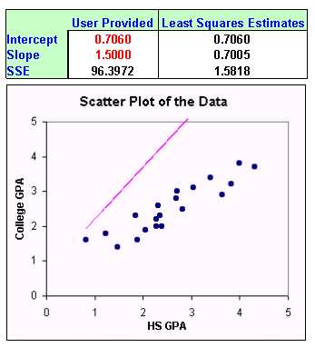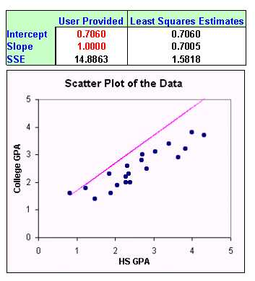
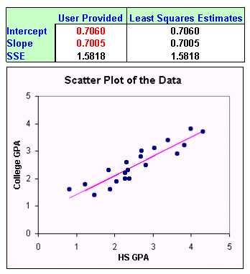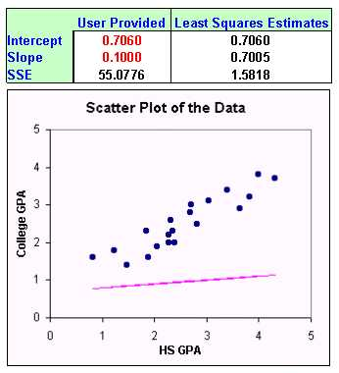

Notice that as the y-intercept and slope get closer to b₀ and b₁, SSE becomes smaller and the line better approximates the relationship between X and Y!

The actual formulas for b₀ and b₁ can be derived through using calculus. The purpose is to find an b₀ and b₁ such that

SSE = 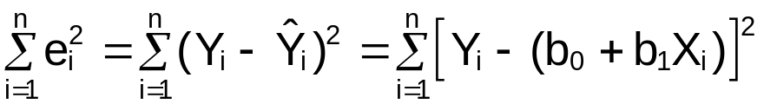

is minimized. Here’s the process:

- Find the partial derivatives with with respect to b₀ and b₁
- Set the partial derivatives equal to 0
- Solve for b₀ and b₁!

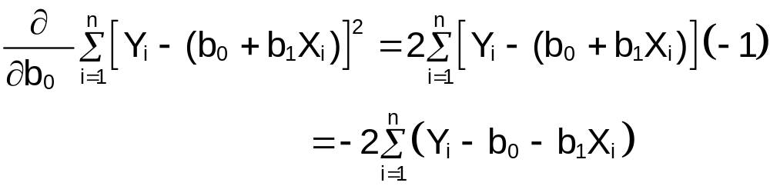

Setting the derivative equal to 0 produces,
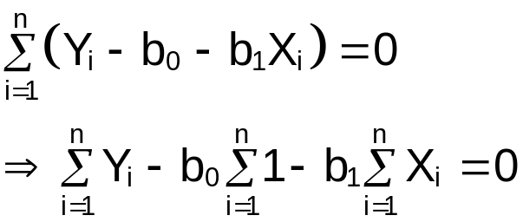
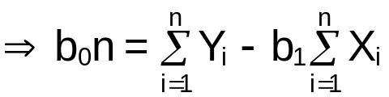
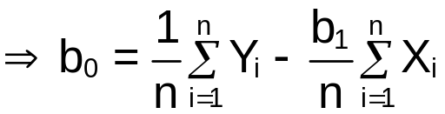 (1)

And,
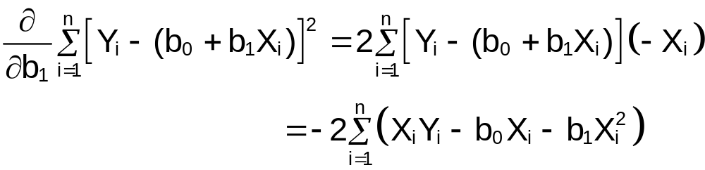

Setting the derivative equal to 0 produces,
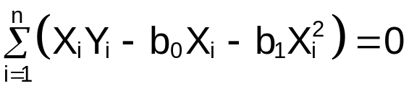 (2)

Substituting (1) into (2) results in,

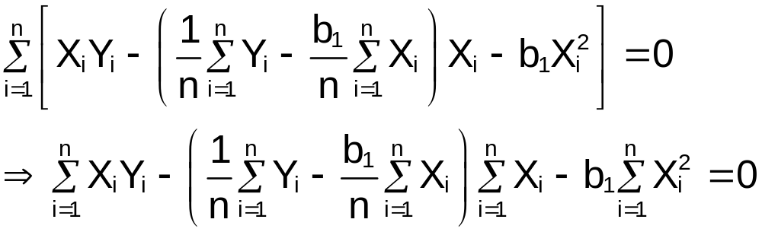
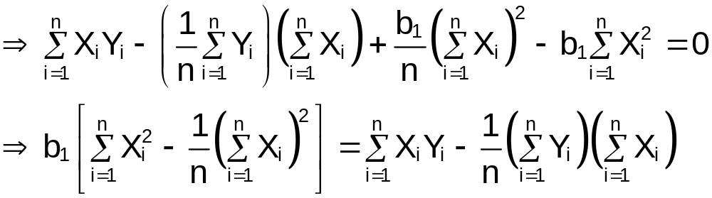
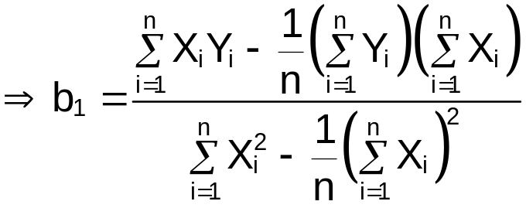

Then b₀ becomes

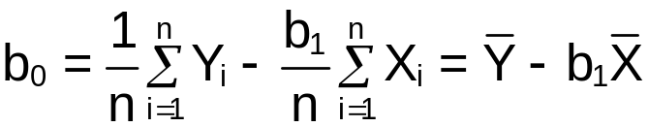

It can be shown that these values do indeed result in a minimum (not a maximum) for SSE.

Properties of least square estimators (Gauss-Markov theorem):
    - Unbiased – 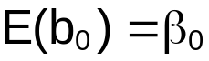 and 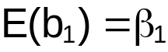
    - Minimum variance among all unbiased estimators

Note that b₀ and b₁ are thought of as random variables here (better to call them B₀ and B₁?). The minimum variance part is proved in STAT 970 (or see Graybill (1976) p. 219)

Why are these properties good?

Reminder of how to work with expected values:

Suppose b and c are constants and W₁ and W₂ are random variables. Then

- E(W₁ + c) = E(W₁) + c
- E(cW₁) = c∗E(W₁)
- E(bW₁ + c) = b∗E(W₁) + c
- E(W₁ + W₂) = E(W₁) + E(W₂)
- E(W₁∗W₂) ≠ E(W₁)∗E(W₂) – except for one specific situation (name that situation!)

Please see my Chapter 4 notes of STAT 380 (www.chrisbilder.com/stat380/schedule.htm) if it has been awhile since you have seen these properties.

Proof of

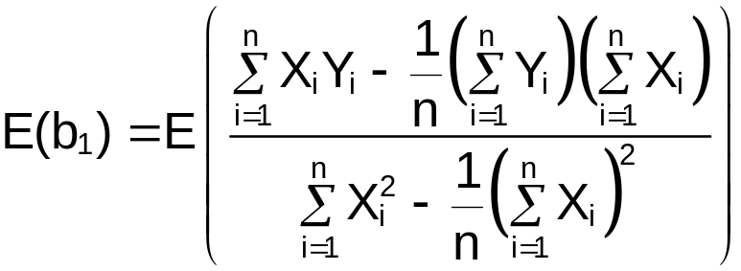
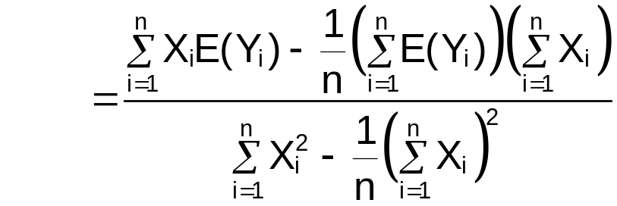
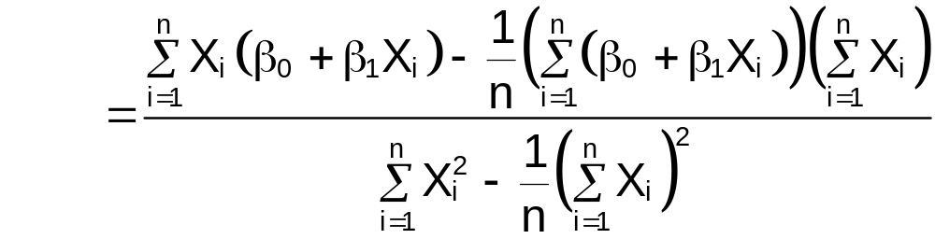
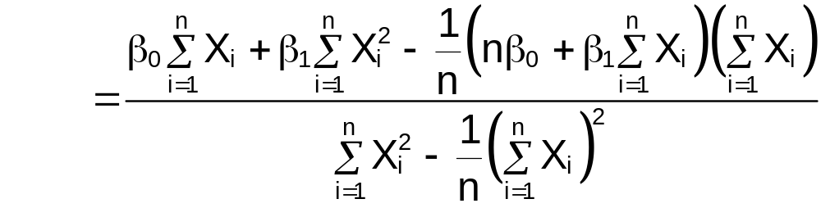
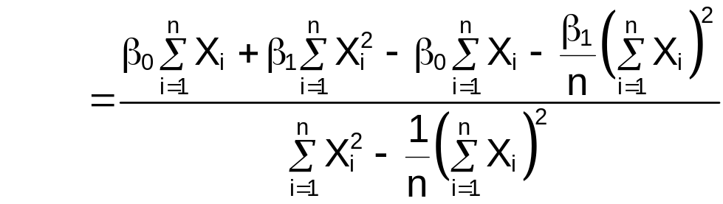
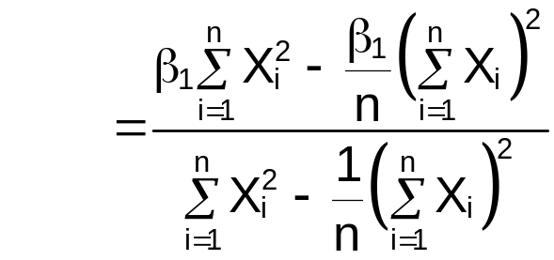
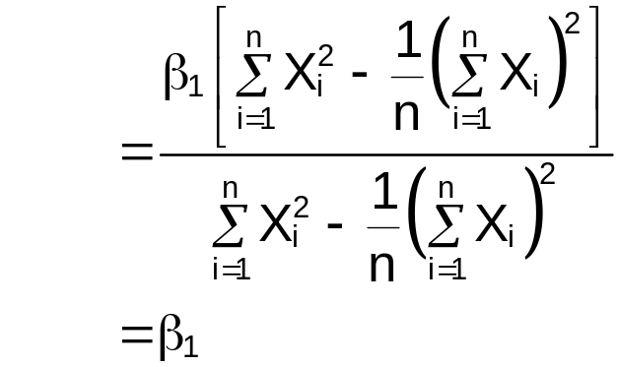

Perhaps this is a simpler proof of :

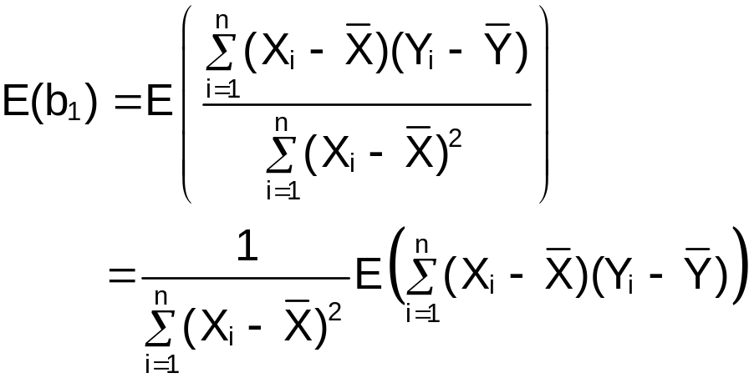
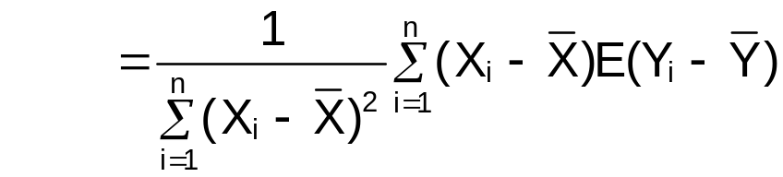
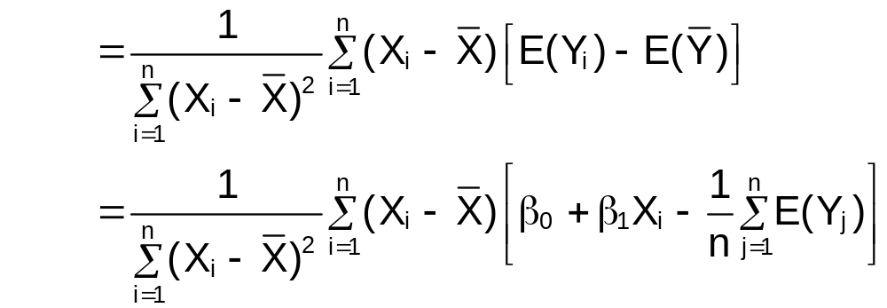
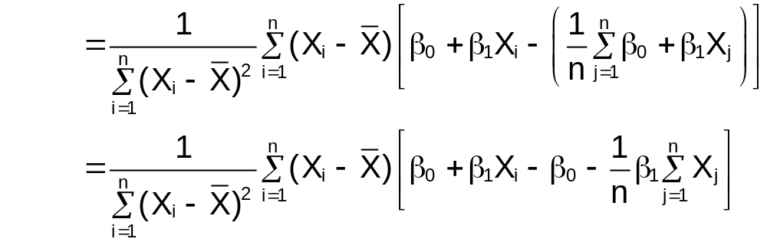
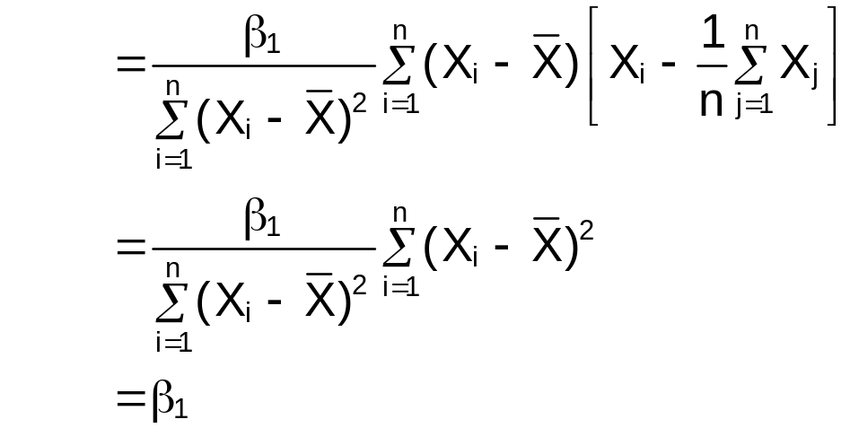
Example: HS and College GPA (HS_college_GPA.R)

See Introduction to R handout first.

The predictor variable is high school GPA (HS.GPA) and the response variable is College GPA (College.GPA). The purpose of this example is to fit a simple linear regression model (sample model) and produce a scatter plot with the model plotted on it.

Below is part of the code close to as it appears after being run in R. Note that I often need to fix the formatting to make it look “pretty” here. This is what I expect your code and output to look like for your projects!

> #########################################################
> # NAME: Chris Bilder #
> # DATE: #
> # PURPOSE: Chapter 1 example with the GPA data set # > # NOTES: 1) #
> # #
> ##########################################################

> #Read in the data
> gpa<-read.table(file = "C:\\chris\\UNL\\STAT870\\
Chapter1\\gpa.txt", header=TRUE, sep = ““)

> #Print data set
> gpa
HS.GPA College.GPA
1 3.04 3.1
2 2.35 2.3
3 2.70 3.0
4 2.05 1.9
5 2.83 2.5
6 4.32 3.7
7 3.39 3.4
8 2.32 2.6
9 2.69 2.8
10 0.83 1.6
11 2.39 2.0
12 3.65 2.9
13 1.85 2.3
14 3.83 3.2
15 1.22 1.8
16 1.48 1.4
17 2.28 2.0
18 4.00 3.8
19 2.28 2.2
20 1.88 1.6

> #Summary statistics for variables
> summary(gpa)
HS.GPA College.GPA
Min. :0.830 Min. :1.400
1st Qu.:2.007 1st Qu.:1.975
Median :2.370 Median :2.400
Mean :2.569 Mean :2.505
3rd Qu.:3.127 3rd Qu.:3.025
Max. :4.320 Max. :3.800

> #Print one variable (just to show how)
> gpa$HS.GPA
[1] 3.04 2.35 2.70 2.05 2.83 4.32 3.39 2.32 2.69 0.83 2.39
3.65 1.85 3.83 1.22
[16] 1.48 2.28 4.00 2.28 1.88

> gpa[,1]
[1] 3.04 2.35 2.70 2.05 2.83 4.32 3.39 2.32 2.69 0.83 2.39
3.65 1.85 3.83 1.22
[16] 1.48 2.28 4.00 2.28 1.88

> #Simple scatter plot
> plot(x = gpa$HS.GPA, y = gpa$College.GPA, xlab = "HS GPA",
ylab = "College GPA", main = "College GPA vs. HS GPA",
xlim = c(0,4.5), ylim = c(0,4.5), col = "red", pch =
1, cex = 1.0, panel.first=grid(col = "gray", lty =
"dotted"))
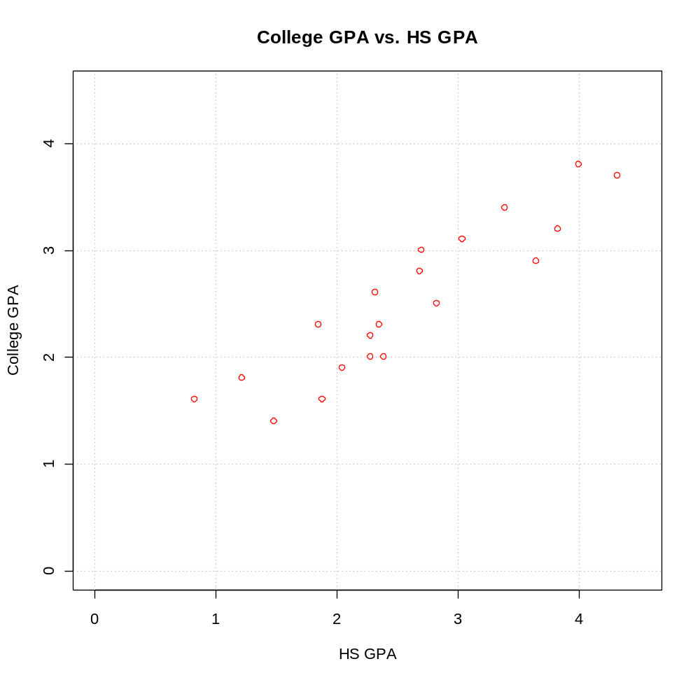

Notes:
- The # denotes a comment line in R. At the top of every program you should have some information about the author, date, and purpose of the program.
- The gpa.txt file is an ASCII text file that looks like:
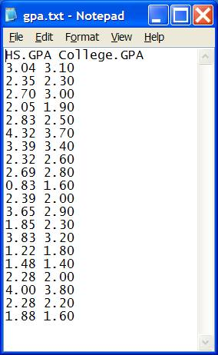
The read.table() function reads in the data and puts it into an object called gpa here. Notice the use of the “\\” between folder names. This needs to be used instead of “\”. Also, you can use “/”. Since the variable names are at the top of the file, the header = TRUE option is given. The sep = “” option specifies white space (spaces, tabs, …) is used to separate variable values. One can use sep = “,” for comma delimited files.
- There are a few different ways to read in Excel files into R. One way is to use the RODBC package. Below is the code that I used to read in an Excel version of gpa.txt.

library(RODBC)
z<-odbcConnectExcel("C:\\chris\\UNL\\STAT875\\R_intro
\\gpa.xls")
gpa.excel<-sqlFetch(z, "sheet1")
close(z)

The data is stored in sheet1 of the Excel file gpa.xls. R puts the data into the object, gpa.excel, with slightly modified variable names.
- You can save an Excel file in a comma delimited format (.csv) and read it into R using read.table() with the option of sep = ",”. Below is the code:

write.table(x = gpa.excel, file = "C:\\chris\\UNL\\
STAT875\\gpa-out.csv", quote = FALSE, row.names =
FALSE, sep=",")

- The gpa object is a object type called a data.frame. To access parts of the objects, I can simply use the following format:
object.name$part.of.object
For example, gpa$HS.GPA provides the HS GPA’s. A data.frame is actually a special type of an object called a list which has elements stored in a matrix format type. Using a form of matrix syntax, I can access parts of the data.frame. For example, gpa[1,1] gives me the first HS GPA observation.
- The summary() function summarizes the information stored within an object. Different object types will produce different types of summaries. An example will be given soon where the summary() function did produce a different type of summary.
- The plot() function creates a two dimensional plot of data. Here are descriptions of its options:
  - x = specifies what is plotted for the x-axis.
  - y = specifies what is plotted for the y-axis.
  - xlab = and ylab = specify the x-axis and y-axis labels, respectively.
  - main = specifies the main title of the plot.
  - xlim = and ylim = specify the x-axis and y-axis limits, respectively. Notice the use of the c() function.
  - col = specifies the color of the plotting points. Run the colors() function to see what possible colors can be used.
  - pch = specifies the plotting characters. Below is a list of possible characters.


  - cex = specifies the height of the plotting characters. The 1.0 is the default.
  - panel.first = grid() specifies grid lines will be plotted. The line types can be specified as follows: 1=solid, 2=dashed, 3=dotted, 4=dotdash, 5=longdash, 6=twodash or as one of the character strings "blank", "solid", "dashed", "dotted", "dotdash", "longdash", or "twodash".
  - The par() function’s Help contains more information about the different plotting options!
- The plot can be brought into Word easily. In R, make sure the plot window is the current window and then select FILE > COPY TO THE CLIPBOARD > AS A METAFILE. Select the PASTE button in Word to paste it.

More code and output:

>###########################################################
> # Find estimated simple linear regression model
> #Fit the simple linear regression model and save the
results in mod.fit

> mod.fit<-lm(formula = College.GPA ~ HS.GPA, data = gpa)

> #A very brief look of what is inside of mod.fit - see
the summary function for a better way
> mod.fit

Call:
lm(formula = College.GPA ~ HS.GPA, data = gpa)

Coefficients:
(Intercept) HS.GPA
0.7076 0.6997

> #See the names of all of the object components
> names(mod.fit)
[1] "coefficients" "residuals" "effects" "rank"
"fitted.values"
[6] "assign" "qr" "df.residual"
"xlevels" "call"
[11] "terms" "model"

> mod.fit$coefficients
(Intercept) HS.GPA
0.7075776 0.6996584

> mod.fit$residuals
1 2 3 4 5 6 7 8
0.26546091 -0.05177482 0.40334475 -0.24187731 -0.18761083 -0.03010181 0.32058048 0.26921493
9 10 11 12 13 14 15 16
0.21034134 0.31170591 -0.37976115 -0.36133070 0.29805437 -0.18726921 0.23883914 -0.34307203
17 18 19 20
-0.30279873 0.29378887 -0.10279873 -0.42293538

> #Put some of the components into a data.frame object
> save.fit<-data.frame(gpa, College.GPA.hat =
round(mod.fit$fitted.values,2), residuals =
round(mod.fit$residuals,2))

> #Print contents of save.fit
> save.fit
HS.GPA College.GPA College.GPA.hat residuals
1 3.04 3.1 2.83 0.27
2 2.35 2.3 2.35 -0.05
3 2.70 3.0 2.60 0.40
4 2.05 1.9 2.14 -0.24
5 2.83 2.5 2.69 -0.19
6 4.32 3.7 3.73 -0.03
7 3.39 3.4 3.08 0.32
8 2.32 2.6 2.33 0.27
9 2.69 2.8 2.59 0.21
10 0.83 1.6 1.29 0.31
11 2.39 2.0 2.38 -0.38
12 3.65 2.9 3.26 -0.36
13 1.85 2.3 2.00 0.30
14 3.83 3.2 3.39 -0.19
15 1.22 1.8 1.56 0.24
16 1.48 1.4 1.74 -0.34
17 2.28 2.0 2.30 -0.30
18 4.00 3.8 3.51 0.29
19 2.28 2.2 2.30 -0.10
20 1.88 1.6 2.02 -0.42

> #Summarize the information stored in mod.fit
> summary(mod.fit)

Call:
lm(formula = College.GPA ~ HS.GPA, data = gpa)

Residuals:
Min 1Q Median 3Q Max
-0.42294 -0.25711 -0.04094 0.27536 0.40334

Coefficients:
Estimate Std. Error t value Pr(>|t|)
(Intercept) 0.70758 0.19941 3.548 0.00230 **
HS.GPA 0.69966 0.07319 9.559 1.78e-08 ***
---
Signif. codes: 0 `***' 0.001 `**' 0.01 `*' 0.05 `.' 0.1 ` ' 1

Residual standard error: 0.297 on 18 degrees of freedom
Multiple R-Squared: 0.8354, Adjusted R-squared: 0.8263
F-statistic: 91.38 on 1 and 18 DF, p-value: 1.779e-08

Notes:
- The lm() function fits the simple linear regression model. The results are stored in an object called mod.fit. Notice the use of the ~ to separate the response and predictor variables. If there were multiple predictor variables, the + sign can be used to separate them.
- By entering the mod.fit object name only, R prints a little information about what is inside of it.
- mod.fit is a type of object called a list. To see a list of the components inside of mod.fit, use the names() function. To access a component of an object, use the $ sign with the name of the component. Refer to the earlier discussion of a data.frame for a similar example.
- To create your own data.frame, you can use the data.frame function. Notice how you can specify the names of columns inside of the data.frame.
- The summary() function can be used with the mod.fit object to summarize the contents of mod.fit. Notice the different results from what we had before with summary()! Without going into too much detail, each object has an “attribute” called class. You can see this by specifying the attributes() or class() functions. For example,

> class(mod.fit)
[1] "lm"

says that mod.fit is of class type lm. The summary() function is what R calls a generic function. This is because it can be used with many different types of classes. When summary(mod.fit) is specified, R first checks the class type and then looks for a function called summary.lm(). Notice the “lm” part was the class type of mod.fit. There is a special function called summary.lm() that is used to summarize objects of type lm! You can see information about the function in the R help. When the summary(gpa) was used earlier, the summary function went to summary.data.frame(). Finally, plot() is also a generic function. The default version of the function used earlier was plot.default() so this is what you need to look up in the help, not plot() itself. Note that there is also a plot.lm() that does a number of plots with objects of class lm.
- The sample regression model is
More code and output:

> #Prediction - note that the actual function used here is
predict.lm()
> predict(object = mod.fit)
1 2 3 4 5 6 7 8
2.834539 2.351775 2.596655 2.141877 2.687611 3.730102 3.079420 2.330785

9 10 11 12 13 14 15 16
2.589659 1.288294 2.379761 3.261331 2.001946 3.387269 1.561161 1.743072

17 18 19 20
2.302799 3.506211 2.302799 2.022935

> new.data<-data.frame(HS.GPA = c(2,3))
> save.pred<-predict(object = mod.fit, newdata = new.data)
> round(save.pred,2)
1 2
2.11 2.81
> ##########################################################
> #Put sample model on plot

> #Open a new graphics window
> win.graph(width = 6, height = 6, pointsize = 10)

> #Same scatter plot as before
> plot(x = gpa$HS.GPA, y = gpa$College.GPA, xlab = "HS
GPA", ylab = "College GPA", main = "College GPA vs.
HS GPA", xlim = c(0,4.5), ylim = c(0,4.5), col =
"red", pch = 1, cex = 1.0, panel.first=grid(col =
"gray", lty = "dotted"))

> #Puts the line y = a + bx on the plot
> abline(a = mod.fit$coefficients[1], b =
mod.fit$coefficients[2], lty = 1, col = "blue",
lwd = 2)

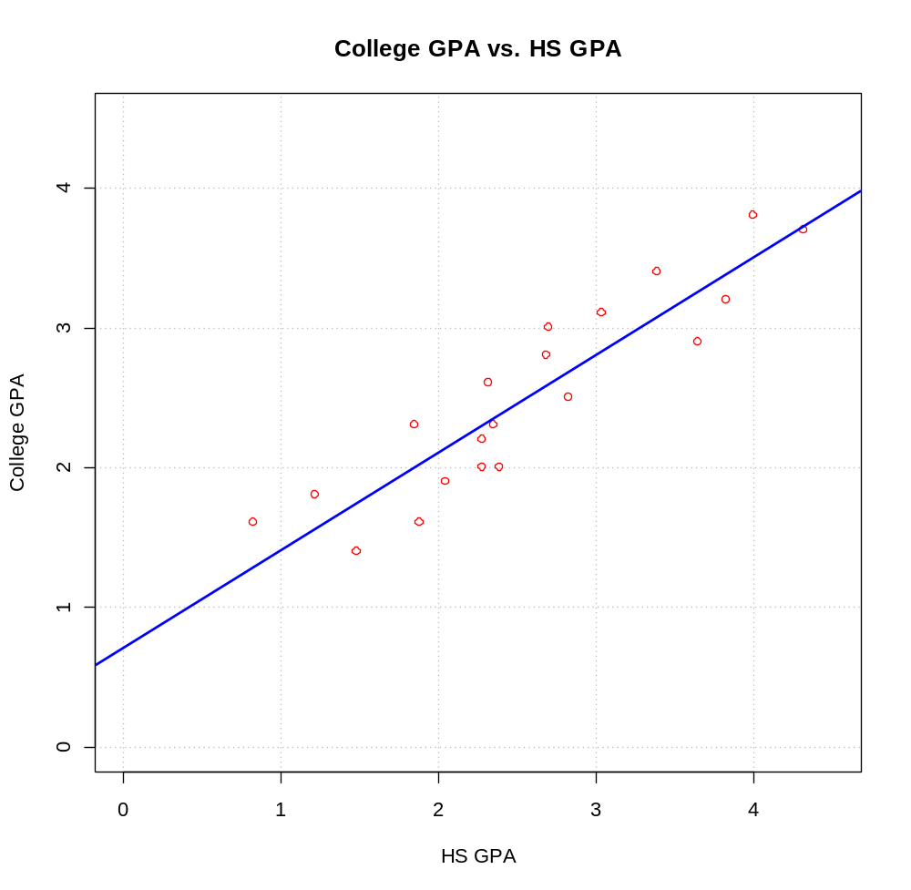
> #Notice the above line goes outside of the range of the
x-values. To prevent this, we can use the segments
function
> #Open a new graphics window - do not need to
> win.graph(width = 6, height = 6, pointsize = 10)

> #Same scatter plot as before
> plot(x = gpa$HS.GPA, y = gpa$College.GPA, xlab = "HS
GPA", ylab = "College GPA", main = "College GPA vs.
HS GPA", xlim = c(0,4.5), ylim = c(0,4.5), col =
"red", pch = 1, cex = 1.0, panel.first=grid(col =
"gray", lty = "dotted"))

> #Draw a line from (x0, y0) to (x1, y1)
> segments(x0 = min(gpa$HS.GPA), y0 =
mod.fit$coefficients[1] +
mod.fit$coefficients[2]*min(gpa$HS.GPA),
x1 = max(gpa$HS.GPA), y1 =
mod.fit$coefficients[1] +
mod.fit$coefficients[2]*max(gpa$HS.GPA),
lty = "solid", col = "blue", lwd = 2)
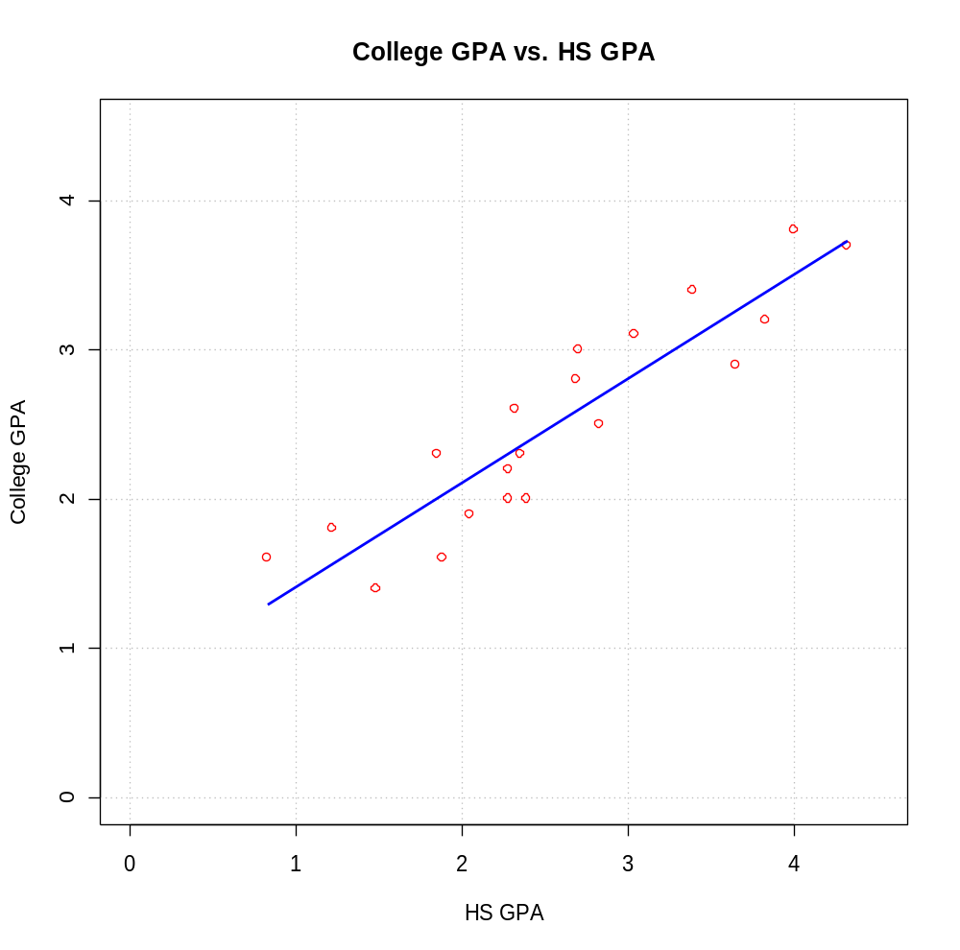

Notes:
- The predict() function can be used to make predictions for a new set of X values. It is a “generic” function like summary(). The actual function called for predict(mod.fit) is predict.lm(mod.fit) since mod.fit has a class type of lm. The main place where knowing this is useful in STAT 870 is when examining the help. Look up predict.lm(), not predict().
- The win.graph() function can be used to open a new plotting window.
- The abline() function can be used to draw straight lines on a plot. In the format used here, the line y = a + bx was drawn where a was the b₀ (intercept) and b was the b₁ (slope).
- In the second plot, the segments() function was used to draw the line on the plot. This was done to have the line within the range of the high school GPA values.
- The curve() function also provides a convenient way to plot the line. Simply, one can use

curve(expr = mod.fit$coefficients[1] +
mod.fit$coefficients[2]*x, xlim =
c(min(gpa$HS.GPA), max(gpa$HS.GPA)), add = TRUE,
col = "blue")

Below is function written to help automate the analysis.

> ##############################################################
> # Create a function to find the sample model
> # and put the line on a scatter plot
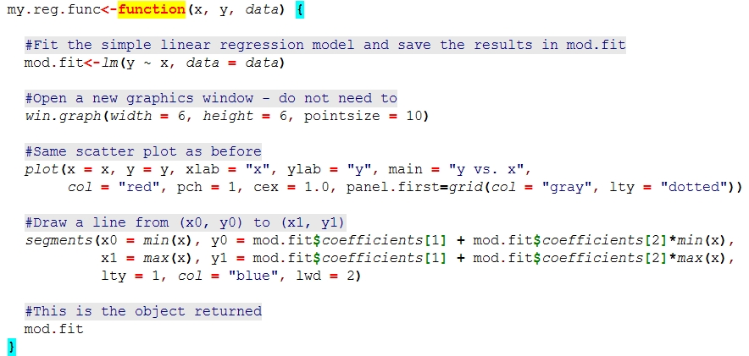

> save.it<-my.reg.func(x = gpa$HS.GPA, y =
gpa$College.GPA, data = gpa)

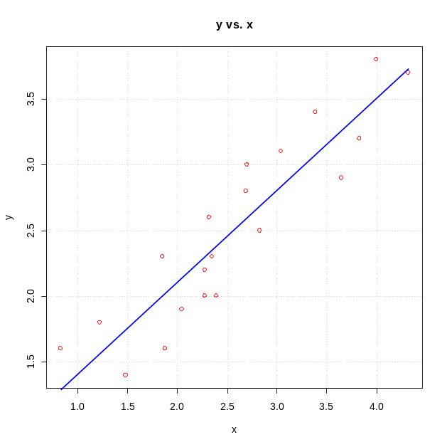

> names(save.it)
[1] "coefficients" "residuals" "effects" "rank"
"fitted.values"
[6] "assign" "qr" "df.residual"
"xlevels" "call"
[11] "terms" "model"

> summary(save.it)

Call:
lm(formula = y ~ x, data = data)

Residuals:
Min 1Q Median 3Q Max
-0.42294 -0.25711 -0.04094 0.27536 0.40334

Coefficients:
Estimate Std. Error t value Pr(>|t|)
(Intercept) 0.70758 0.19941 3.548 0.00230 **
x 0.69966 0.07319 9.559 1.78e-08 ***
---
Signif. codes: 0 `***' 0.001 `**' 0.01 `*' 0.05 `.' 0.1 ` ' 1

Residual standard error: 0.297 on 18 degrees of freedom
Multiple R-Squared: 0.8354, Adjusted R-squared: 0.8263
F-statistic: 91.38 on 1 and 18 DF, p-value: 1.779e-08

Final notes for this example:
- Typing a function name only, like lm, will show you the actual code that is used by the function to do the calculations! This can be useful when you want to know more about how a function works or if you want to create your own function by modifying the original version. Often, you will see code within a function like .C or .Fortran. These are calls outside of R to a C or Fortran program that is inside of the R installation.
- Please remember to always use the Help if you do not understand a particular function!
- The first two pages of Vito Ricci’s R reference card for regression (http://cran.r-project.org/doc/contrib/Ricci-refcard-regression.pdf) provides a helpful summary of many of the functions we will use in this course.
- Mathematical expressions can be put on plots using the expression() function. For example,

> plot(x = gpa$HS.GPA, y = gpa$College.GPA, xlab = "HS
GPA", ylab = "College GPA", main =
expression(paste("College GPA vs. HS GPA and ",
widehat(College.GPA) == hat(beta)[0]
hat(beta)[1]*HS.GPA)), xlim = c(0,4.5), ylim = c(0,4.5),
col = "red", pch = 1, cex = 1.0, panel.first=grid(col =
"gray", lty = "dotted"))
> segments(x0 = min(gpa$HS.GPA), y0 =
mod.fit$coefficients[1] + mod.fit$coefficients[2]
* min(gpa$HS.GPA), x1 = max(gpa$HS.GPA), y1 =
mod.fit$coefficients[1] + mod.fit$coefficients[2]
* max(gpa$HS.GPA), lty = 1, col = "blue", lwd = 2)
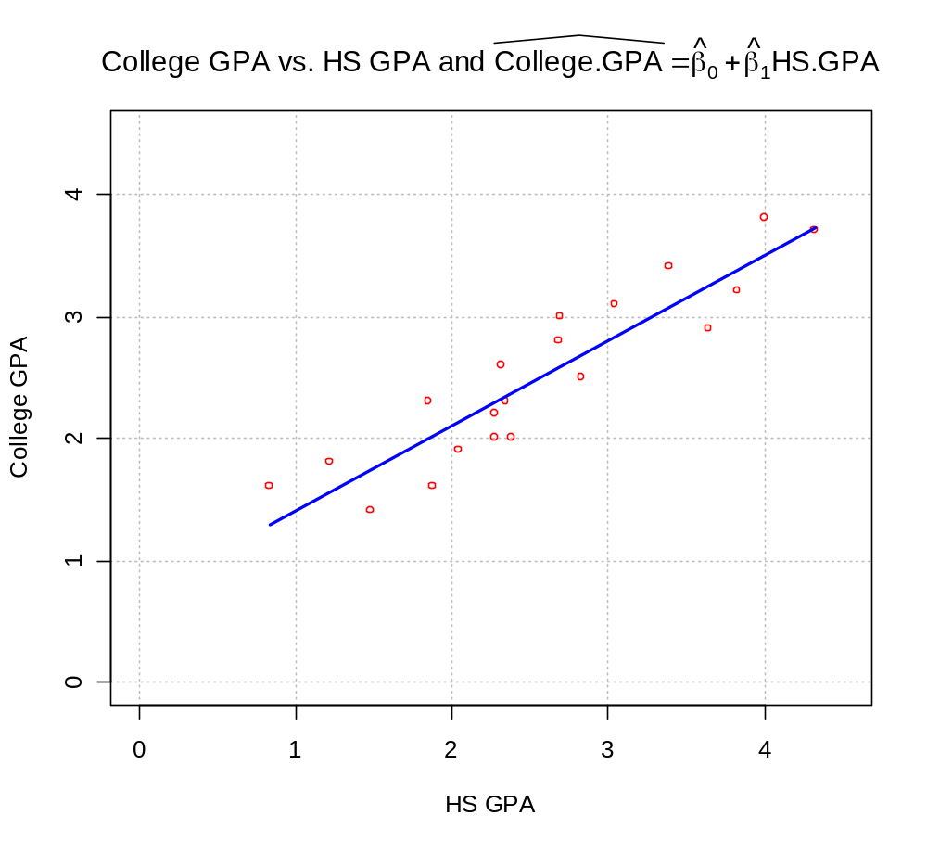
Note that the paste() function was used to put characters together in the title of the plot. Run demo(plotmath) at an R Console prompt for help on the code.
- To get specific x-axis or y-axis tick marks on a plot, use the axis() function. For example,

#Note that xaxt = "n" tells R to not give any labels on the
# x-axis (yaxt = "n" works for y-axis)
plot(x = gpa$HS.GPA, y = gpa$College.GPA, xlab = "HS GPA",
ylab = "College GPA", main = "College GPA vs. HS GPA",
xaxt = "n", xlim = c(0, 4.5), ylim = c(0, 4.5), col =
"red", pch = 1)
#Major tick marks
axis(side = 1, at = seq(from = 0, to = 4.5, by = 0.5))
#Minor tick marks
axis(side = 1, at = seq(from = 0, to = 4.5, by = 0.1), tck =
0.01, labels = FALSE)

- Why is Excel not used? Unfortunately, Excel does not have the enough statistical analyses or flexibility to suit the needs of our class. Also, Excel has been to shown to be computationally incorrect in a number of cases. While Excel is nice for simple statistics (≤ simple linear regression analysis), it is often not good to use for anything more complex. Note that a R package called “Rexcel” is available that allows you to use R within Excel.
- R is often referred to as an objected oriented language. This is because generic functions, like summary(), can lead to different results due to the class of the object used with it. As discussed earlier, R first checks an object's class type when a generic function is run. R will then look for a “method” function with the name format <generic function>.<class name>. For example, summary(mod.fit) finds the function summary.lm() that summarizes fits from regression models.
The purpose of generic functions is to use a familiar language set with any object. For example, we frequently want to summarize data or a model (summary()), plot data (plot()), and find predictions (predict()), so it is convenient to use the same language set no matter the application. The object class type determines the function action. Understanding generic functions may be one of the most difficult topics for new R users. One of the most important points students need to know now is where to find help for these functions. For example, if you want help on the results from summary(mod.fit), examine the help for summary.lm() rather than the help for summary() itself.

To see a list of all method functions associated with a class, use methods(class = <class name>), where the appropriate class name is substituted for <class name>. For our regression example, the method functions associated with the lm class are:

> methods(class = lm)
[1] add1.lm* alias.lm* anova.lm
case.names.lm* confint.lm*
cooks.distance.lm*

<OUTPUT EDITED>

[31] rstudent.lm simulate.lm* summary.lm
variable.names.lm* vcov.lm*

Non-visible functions are asterisked

To see a list of all method functions for a generic function, use methods(generic.function = <generic function name>) where the appropriate generic function name is substituted for <generic function name>. Below are the method functions associated with summary():

> methods(generic.function = summary)
[1] summary.aov summary.aovlist
summary.aspell* summary.connection
summary.data.frame

<OUTPUT EDITED>

[26] summary.stepfun summary.stl*
summary.table summary.tukeysmooth*

Non-visible functions are asterisked

- When you become more advanced with your R coding, check out http://google-styleguide.googlecode.com/svn
/trunk/google-r-style.html for a style guide to it. By having one standard style to writing code, it becomes easier for everyone to read it.
- The R listserv is useful to search when you are having difficulties with code. You can search it at http://finzi.psych.upenn.edu/search.html.
- My favorite R blog is http://blog.revolutionanalytics.com, which is published by Revolution Analytics (a company that “sells” its own version of R).
- Are there any point-and-click ways to produce plots or output? Yes, the Rcmdr (short for “R Commander”) package can for many statistical methods. This package does not come with the initial installation of R, so you will need to install it. Once the package is installed, use library(package = Rcmdr) to start it. The first time that you run this code, R will ask if you want to install a number of other packages. Select yes, but note that this may take some time to install all of them. Once a data set is loaded into R Commander (select the box next to “Data set:”), various drop down window options can be chosen to complete the desired analysis.
- Are there any point-and-click methods to use in R to do the analyses here? Yes – Rcmdr (short for “R Commander”) is a package that allows for some point-and-click calculations. This package does not come downloaded with the initial installation of R so you will need to install it (will take a little bit of time because it automatically installs other packages as well). Once the package is installed, simply use library(Rcmdr) to start it. Below is what it looks like with some actual code that I typed into it and use the SUBMIT button to run.

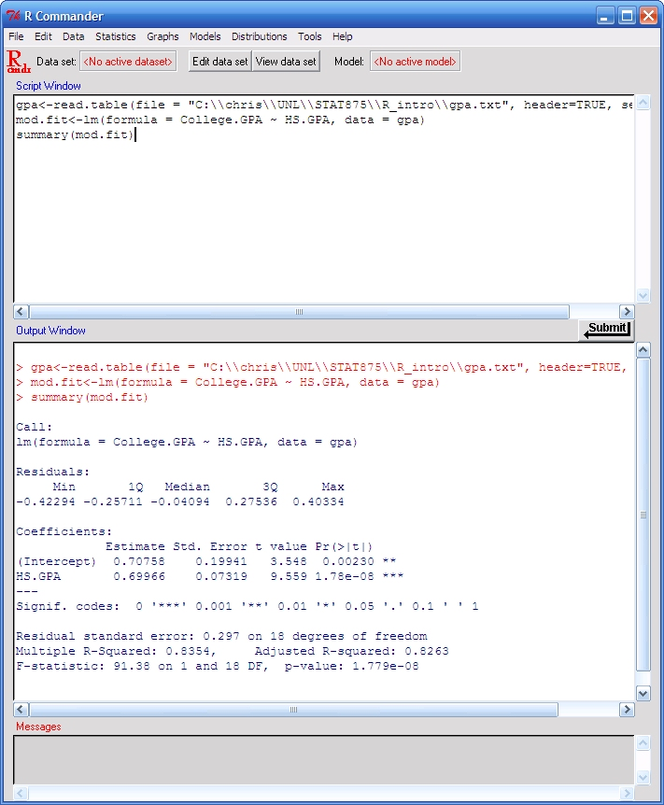

One of the nice things about R Commander is that you can use it to help learn the code through using its point-and-click interface. To begin, you need to specify the data set of interest. Since gpa already exists in my current R session, I choose this data set by selecting DATA > ACTIVE DATA SET > SELECT ACTIVE DATA SET to bring up the screen below.

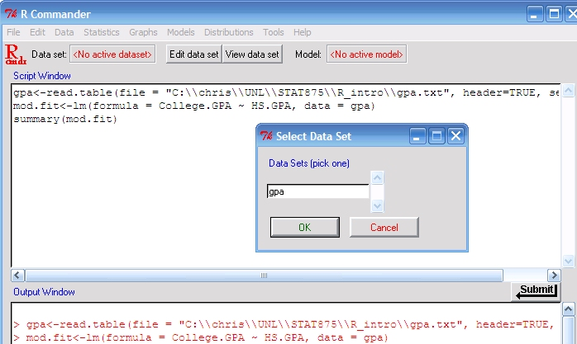

Next, I select the gpa data set and OK. Now R knows that you want to use this data set for any of the point-and-click analysis tools. For example, select STATISTICS > SUMMARIES > ACTIVE DATA SET to have the following sent to the OUTPUT window:

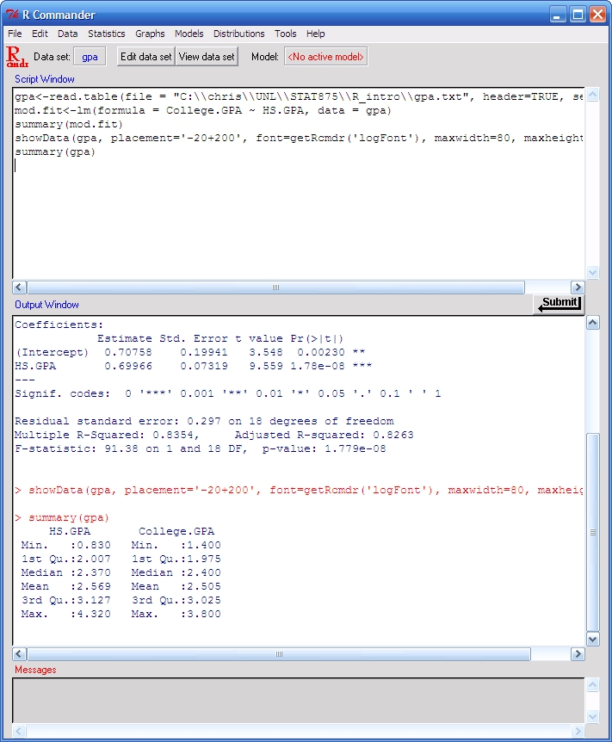

Notice how R uses the summary() function just like we did before to print summary statistics for each variable. The SCRIPT window keeps track of this code.

To find the sample sample simple linear regression model, select STATISTICS > FIT MODELS > LINEAR REGRESSION to bring up the following window:

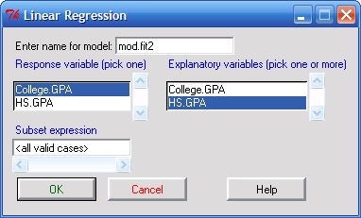

I have already highlighted the correct variables and typed in the name for the object to contain the needed information. Here’s what happens after selecting OK,

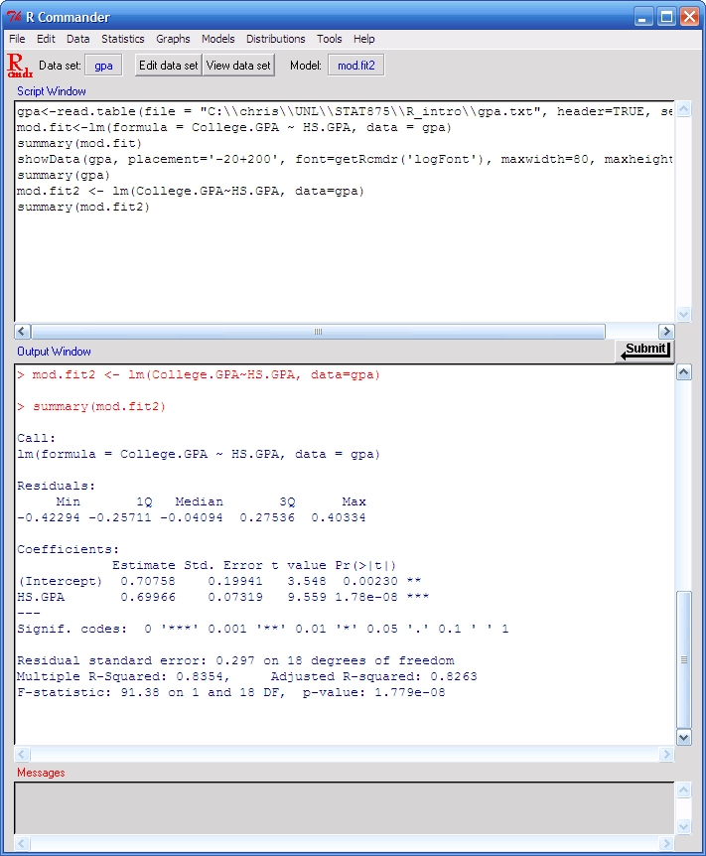

Again, the same type of code as we used before is shown here. As you can see, the R Commander may be a useful tool to use when trying to learn the code. We will have more complicated items in the future where it will not be possible (or at least very inconvenient) to use R Commander. Also, using a code editor that uses color will make your program code much easier to read!

Estimating σ²

Population simple linear regression model: Y_{i}=β_{o} + β₁X_{i} + ε_{i} where ε_{i} ~ independent N(0,σ²)

σ² measures the variability of the ε_{i} in the graph below
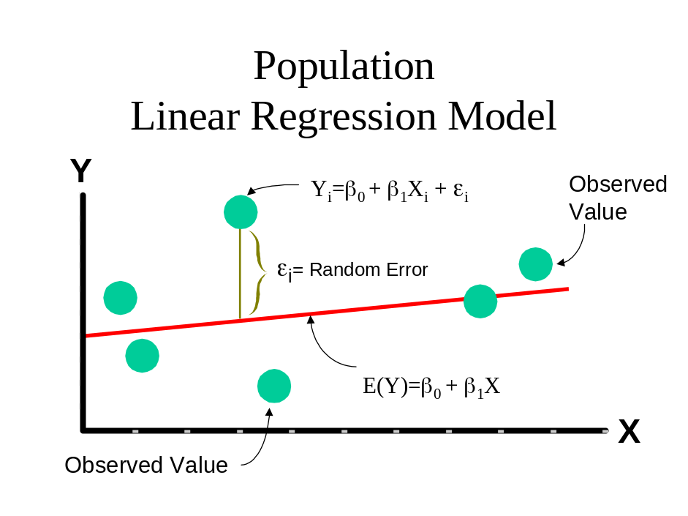

Estimate σ² using the variability in the residuals, e_{i}=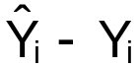
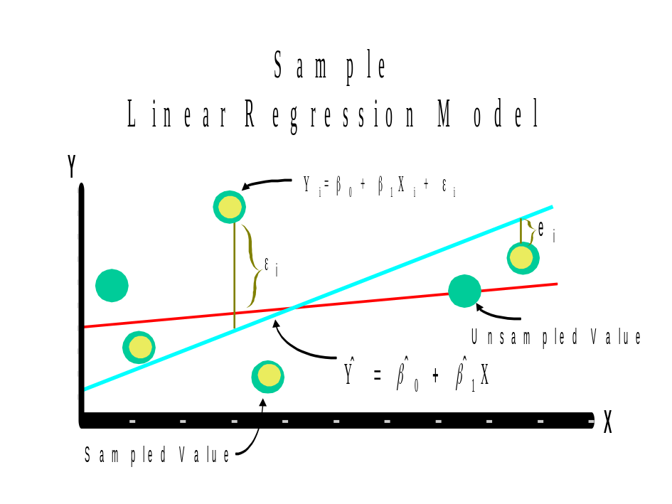

Review from a previous STAT class:

Suppose there is one population and you are interested in estimating the variability. This can be done by calculating the sample variance,
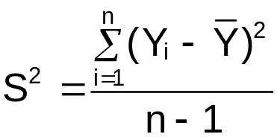.
S² measures the variability of the Y_{i} around the sample mean, .

A similar measure to S² is used in regression to measure the variability of the Y_{i} around 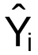. This measure is the mean square error (MSE):
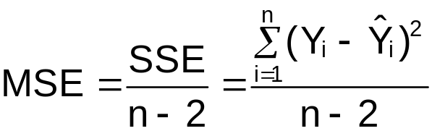

Note that the SSE has n-2 degrees of freedom associated with it. Two degrees of freedom are lost due to the estimation of β₀ and β₁
.

Question: Which plot is associated with the higher MSE? Note that the same X values are used in both plots.

1)
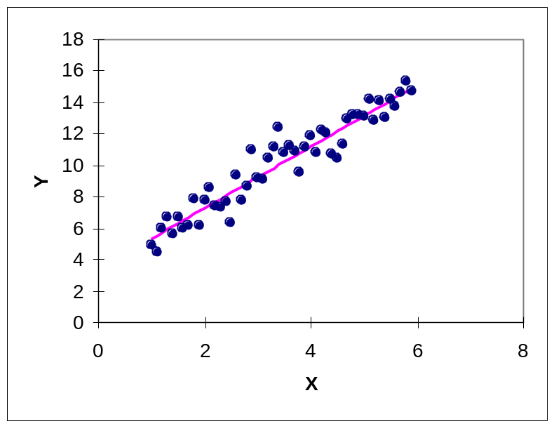

2)
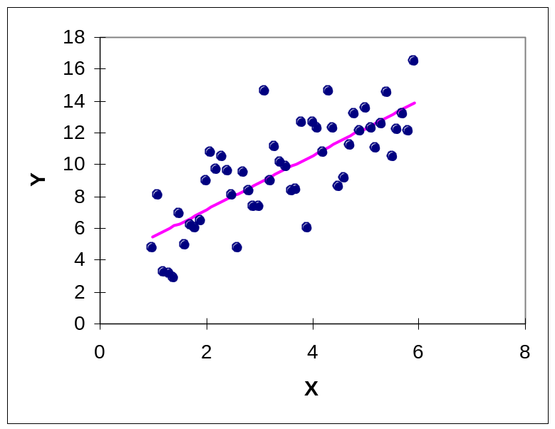

Practical interpretation of MSE

Rule of thumb: Most data lies within ± 2 to 3 standard deviations from the mean (see the empirical rule, assuming a mound shape distribution).
- Here, plays the role of the mean and  plays the role of the standard deviation.
- So all of the Y values should lie between ±2* for a particular X

Example: Sales and Advertising

X | Y |  | Y- | (Y-)²
1 | 1 | 0.6 | 0.4 | 0.16
2 | 1 | 1.3 | -0.3 | 0.09
3 | 2 | 2 | 0 | 0
4 | 2 | 2.7 | -0.7 | 0.49
5 | 4 | 3.4 | 0.6 | 0.36
Σ |  |  |  | 1.1

MSE = Σ(Y-)²/(n-2) = 1.1/(5-2) = 0.3667

NOTE: 2* = 1.2111

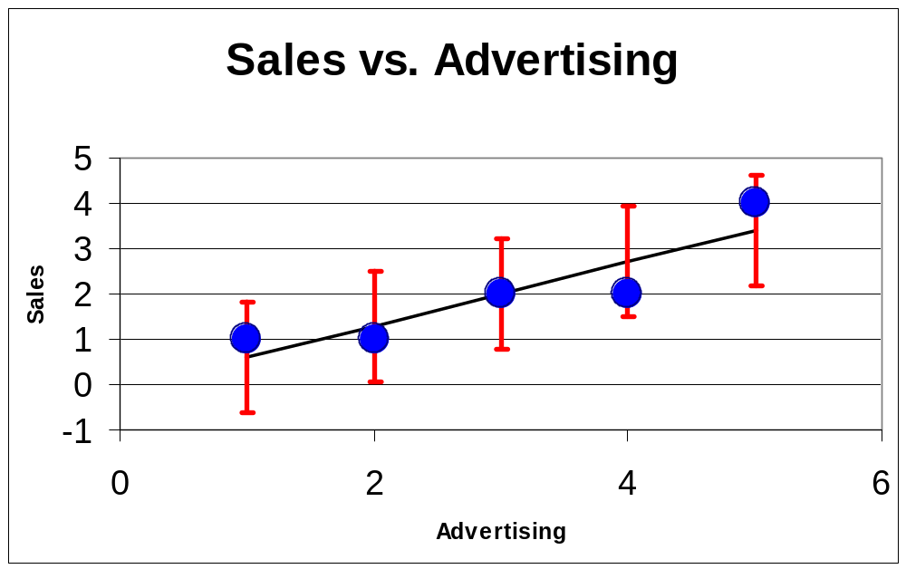

Example calculation:

For X=4,
± 2* = 2.7 ± 1.2111
= (1.4889, 3.9111)

Therefore for all observations in the data set with X=4, one would expect all the corresponding Y values to be between 1.49 and 3.91.

Example: HS and College GPA (HS_college_GPA.R)

From earlier,

> summary(mod.fit)

Call:
lm(formula = College.GPA ~ HS.GPA, data = gpa)

Residuals:
Min 1Q Median 3Q Max
-0.42294 -0.25711 -0.04094 0.27536 0.40334

Coefficients:
Estimate Std. Error t value Pr(>|t|)
(Intercept) 0.70758 0.19941 3.548 0.00230 **
HS.GPA 0.69966 0.07319 9.559 1.78e-08 ***
---
Signif. codes: 0 `***' 0.001 `**' 0.01 `*' 0.05 `.' 0.1 ` ' 1

Residual standard error: 0.297 on 18 degrees of freedom
Multiple R-Squared: 0.8354, Adjusted R-squared: 0.8263
F-statistic: 91.38 on 1 and 18 DF, p-value: 1.779e-08

From the above output, = 0.297. And,

> 0.297^2
[1] 0.088209

is MSE. Using ± 2* in the same type of Excel plot as in the previous example produces,

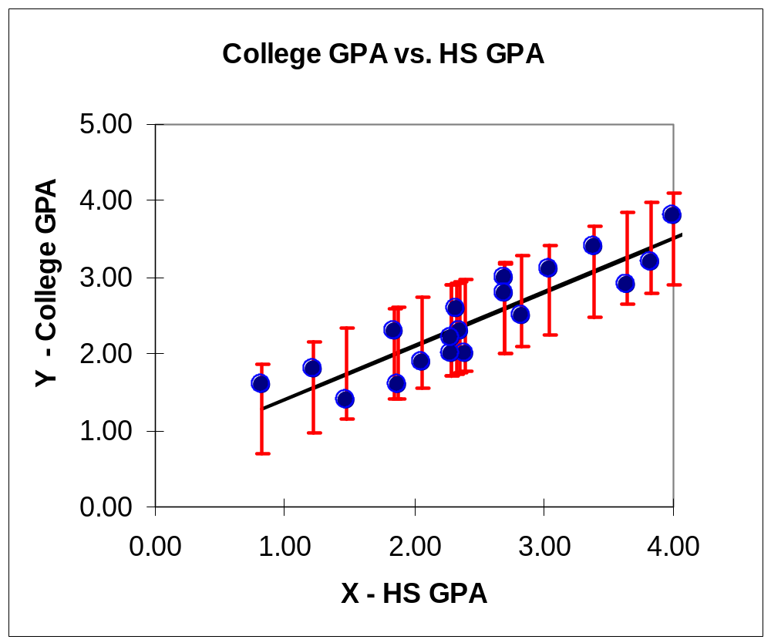

To help you with learning R, here are two other ways to find the MSE. Method #1:

> names(mod.fit)
[1] "coefficients" "residuals" "effects" "rank"
[5] "fitted.values" "assign" "qr" "df.residual"
[9] "xlevels" "call" "terms" "model"

> mod.fit$residuals
1 2 3 4 5
0.26546091 -0.05177482 0.40334475 -0.24187731 -0.18761083

6 7 8
-0.03010181 0.32058048 0.26921493

9 10 11 12 13 0.21034134 0.31170591 -0.37976115 -0.36133070 0.29805437
14 15 16
–0.18726921 0.23883914 -0.34307203

17 18 19 20
-0.30279873 0.29378887 -0.10279873 -0.42293538

> sum(mod.fit$residuals^2)/mod.fit$df.residual
[1] 0.08822035

Method #2:

> #Method #2
> summary.fit<-summary(mod.fit)
> names(summary.fit)
[1] "call" "terms" "residuals" "coefficients" "aliased"
[6] "sigma" "df" "r.squared" "adj.r.squared" "fstatistic"
[11] "cov.unscaled"

> summary.fit$sigma
[1] 0.2970191
> summary.fit$sigma^2
[1] 0.08822035

Note: This type of interpretation for MSE will be used again for residual plots in Chapter 3.

Model assumptions

At each possible X value, Y has a normal probability distribution function (PDF) with E(Y) = β₀ + β₁X and Var(Y) = σ². Why?

ε is a normal random variable with E(ε) = 0 and Var(ε) = σ². Thus,

Var(Y) = Var(β₀ + β₁X + ε)
= Var(ε) since β₀ + β₁X is a constant
= σ²

E(Y) = E(β₀ + β₁X + ε)
= E(β₀) + E(β₁X) + E(ε)
= β₀ + β₁X + 0
= β₀ + β₁X (also shown on p. 1.8)

For each X, we can then use the normal PDF to understand what range we would expect the Y observations to fall within. For example,

P[E(Y) - 2σ < Y < E(Y) + 2σ] = 0.954

⇒ P[β₀ + β₁X - 2σ < Y < β₀ + β₁X + 2σ] = 0.954

Please remember that Y is dependent on the particular value of X here.

Below is an illustration of how Y has a normal PDF at each X.
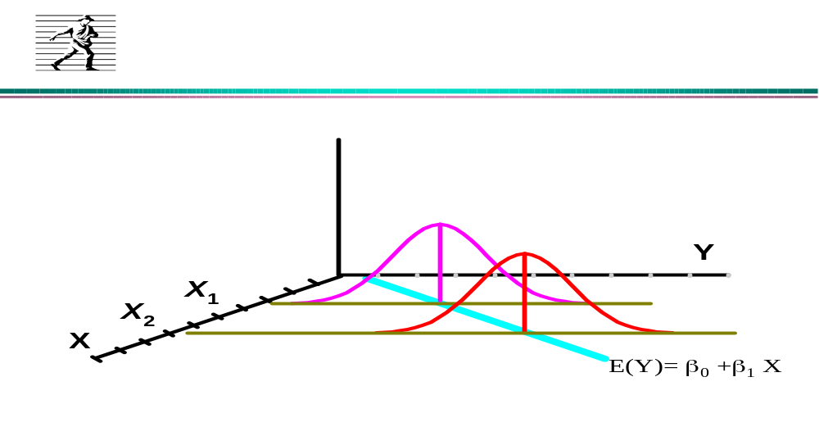

Also see p. 30 for a partially related discussion.

Remember that σ² controls the spread of the normal distributions above. Compare the spread illustrated here to the plots on p. 1.57 and p. 1.59.

